**UNIT-1**

**Digital Computers:**

Introduction:

A Digital computer can be considered as a digital system that performs various computational tasks.

The first electronic digital computer was developed in the late 1940s and was used primarily for numerical computations.

By convention, the digital computers use the binary number system, which has two digits: 0 and 1. A binary digit is called a bit.

A computer system is subdivided into two functional entities: Hardware and Software.

The hardware consists of all the electronic components and electromechanical devices that comprise the physical entity of the device.

The software of the computer consists of the instructions and data that the computer manipulates to perform various data-processing tasks.

**Block diagram of a Digital Computer**

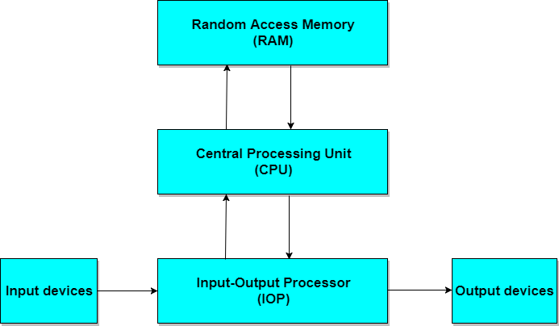

* The Central Processing Unit (CPU) contains an arithmetic and logic unit for manipulating data, a number of registers for storing data, and a control circuit for fetching and executing instructions.
* The memory unit of a digital computer contains storage for instructions and data.
* The Random Access Memory (RAM) for real-time processing of the data.
* The Input-Output devices for generating inputs from the user and displaying the final results to the user.
* The Input-Output devices connected to the computer include the keyboard, mouse, terminals, magnetic disk drives, and other communication devices.

## Digital Computers: Computer Architecture

Computer Architecture is concerned with the structure and behaviour of the computer as seen by the user.

It includes the information, formats, the instruction set, and techniques for addressing memory. The architectural design of a computer system is concerned with the specifications of the various functional modules, such as processors and memories, and structuring them together into a computer system.

Two basic types of computer architecture are:

1. **von Neumann architecture**
2. **Harvard architecture**

### 1. von Neumann architecture

The **von Neumann architecture** describes a general framework, or structure, that a computer's hardware, programming, and data should follow. Although other structures for computing have been devised and implemented, the vast majority of computers in use today operate according to the von Neumann architecture.

von Neumann envisioned the structure of a computer system as being composed of the following components:

1. **ALU:** The **Arithmetic-Logic unit** that performs the computer's computational and logical functions.
2. **RAM:** Memory; more specifically, the computer's main, or fast, memory, also known as **Random Access Memory(RAM)**.
3. **Control Unit**: This is a component that directs other components of the computer to perform certain actions, such as directing the fetching of data or instructions from memory to be processed by the ALU; and
4. **Man-machine interfaces;** i.e. input and output devices, such as keyboard for input and display monitor for output.
5. An example of computer architecture base on the von Neumann architecture is the desktop **personal computer**.

### 2. Harvard architecture:

The **Harvard architecture** uses physically separate **storage** and **signal pathways** for their instructions and data. The term originated from the **Harvard Mark I** and the data in relay latches (23- digits wide).

In a computer with Harvard architecture, the CPU can read both an instruction and data from memory at the same time, leading to double the memory bandwidth.

**Microcontroller**(single-chip microcomputer)-based computer systems and **DSP**(Digital Signal Processor)-based computer systems are examples of Harvard architecture.

**Computer Organization:**

**Computer Organization is concerned with the structure and behaviour of a computer system as seen by the user.**

It deals with the components of a connection in a system

Computer Organization tells us how exactly all the units in the system are arranged and interconnected.

Whereas Organization expresses the realization of architecture.

An organization is done on the basis of architecture.

Computer Organization deals with low-level design issues.

Organization involves Physical Components (Circuit design, Adders, Signals, Peripherals)

# Computer Architecture :

# Computer Architecture is concerned with the way hardware components are connected together to form a computer system.

# It acts as the interface between hardware and software.

# Computer Architecture helps us to understand the functionalities of a system.

# A programmer can view architecture in terms of instructions, addressing modes and registers.

# While designing a computer system architecture is considered first.

# Computer Architecture deals with high-level design issues.

# Architecture involves Logic (Instruction sets, Addressing modes, Data types, Cache optimization)

# Computer Architecture VS Computer Organization

|  |  |
| --- | --- |
| **Computer Architecture** | **Computer Organization** |
| Computer Architecture is concerned with the way hardware components are connected together to form a computer system. | Computer Organization is concerned with the structure and behaviour of a computer system as seen by the user. |
| It acts as the interface between hardware and software. | It deals with the components of a connection in a system. |
| Computer Architecture helps us to understand the functionalities of a system. | Computer Organization tells us how exactly all the units in the system are arranged and interconnected. |
| A programmer can view architecture in terms of instructions, addressing modes and registers. | Whereas Organization expresses the realization of architecture. |
| While designing a computer system architecture is considered first. | An organization is done on the basis of architecture. |